**Steps to Create Documentation**

1. Go to Terminal; then go to folder where are code files (**cd folderName**)

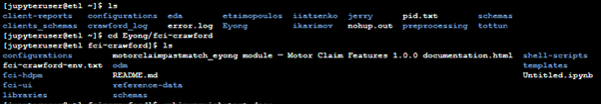

1. Install Sphinx library using **PIP command (pip install Sphinx)**

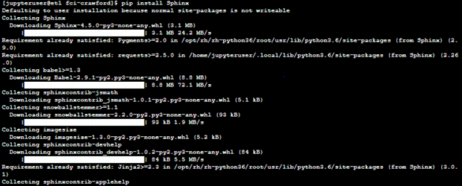

1. Now make documentation project here and execute following command

**sphinx-quickstart docs**

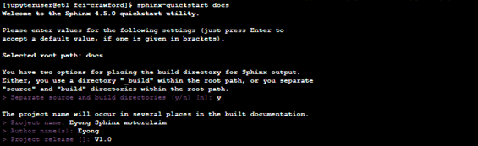

1. Now check you will have folder created and files created in the directory (**folder name is docs**) – The structure of this directory will be:-

* docs
  + source (**here you will place your python file**) – There you will find two important files
    - index.rst
    - conf.py
  + build (After successful process, your final documentation will be here)
    - html
      * index.html (**launch this to see documentation**)
  + make.bat (**ignore this**)
  + MakeFile (**ignore this**)



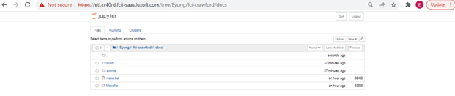

1. Now before placing your script, **open conf.py file and uncomment these lines**

|  |
| --- |
| import os  import sys  sys.path.insert(0, os.path.abspath('.')) |

**Now replace extension = [] by following**:

|  |
| --- |
| extensions = [  "sphinx.ext.autodoc",  "sphinx.ext.viewcode",  ] |

1. Save file and now **copy your python file to docs/source folder**
2. My python file name was “**motorclaimpastmatch_eyong.py**”



1. Now **open index.rst file inside docs/source folder**

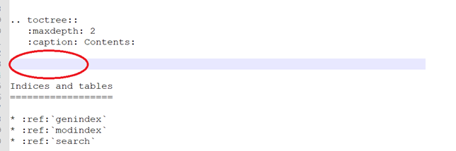

1. **Add your python file(s) name(s) here (shown in red circle)**

**Note:** don’t use python extension – use without **“.py”**

1. Now go to source folder using command (**cd docs/source**) then use following command

**sphinx-apidoc -o . .**

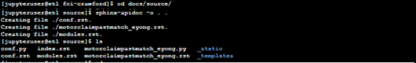

1. Execute following commands

**cd ..**

**cd ..**

**sphinx-build -b html docs/source/ docs/build/html**

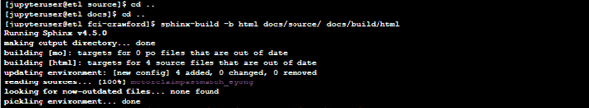

1. Now go to **docs/build/html** folder, you will see multiple files (**open index.html**)

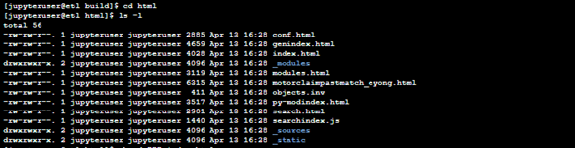

1. Open index.html and check easy documentation of source code